Links:
Questions ,
Least common multiple

What is factor and Multiple?
10,15,20,25 are all multiples of 5
Factor is what u get when u multiply a number with another number.
Factor pair Result
(5,3),(15,1) 15 | 5,3 are factors of 15

What is common multiple and common factor?
Common factor: given a set of numbers, a common factor is numbers which exactly divides every number in our set.
Common multiple: given a set of number, a common multiple is a number which comes in the table of every number in our set.

Prime factorization:
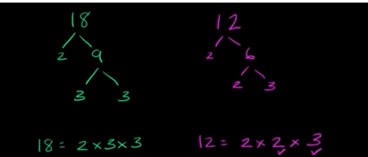

LCM: (Least common multiple)


Ans:
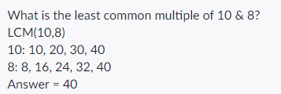

To do this with prime factorization:

Its like saying we need a number which is divisible by both 10,8
x%10=0 and x%8=0
which can be represented as
x/2*5 and x/2*2*2
>>>
=2*5*2*2
=2*5*4
ans=40
LCM(10,8)=40
NOTE:
Least common multiple:
given a set of numbers, find a numbers that comes in the table fo every number in our set.

Another e.g
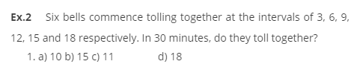

Ans is 15
Ex 3
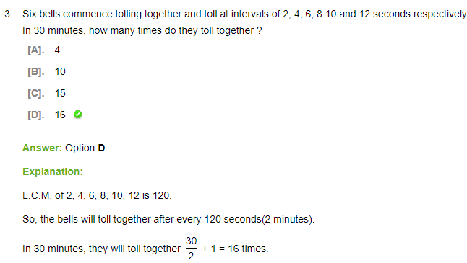
Here 1 is bcoz we said six bells commence tolling together.
E.g)
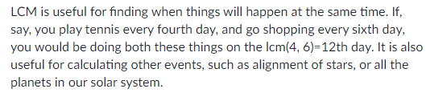

E.g)


A Bit not sure of below ans


Greatest/Highest Common Divisor/Factor
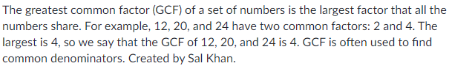
If u got nothing in common the gcd is 1
Another e.g
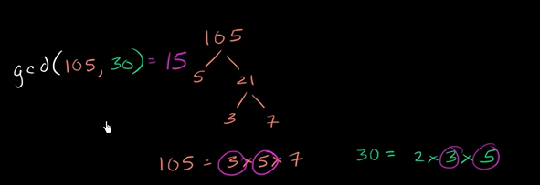

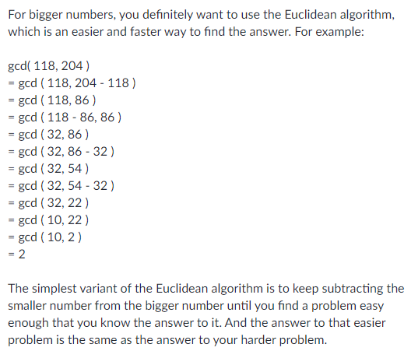

GCF & LCM word problem
khanacademy
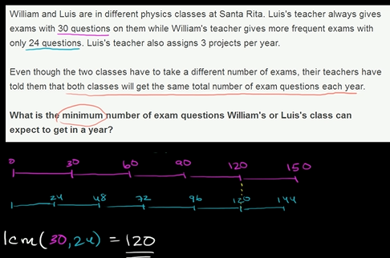

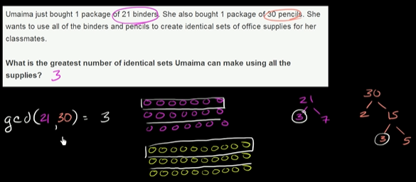

Note 1:
Gcd Intuition:
we are finding a biggest number that is dividing them both.
Above we got max(3,1)=3
Note 2.
x/3 u r actually making pieces of size 3, irrelevant whether it is divisible or not.
Note 3:
so basically for the binders and pencils, you got 3 set for each of them.
{ (21b/3, 30p/3) , (21b/3, 30p/3) , (21b/3, 30p/3) }
Note 4:
You want equality
There is no such thing as Least common factor cuz ans is always 1.

